“FREE” Zoom Drawing Class
with
Carl Purcell

***May 16, 2024 (THURS.)***

TIME: 1:00 p.m. – 4:00 p.m.
PLACE: In the comfort of your own home
*COST: FREE for current members only

Workshop Description: There have been many requests for a drawing workshop to supplement your watercolor work. Join Carl Purcell in this free drawing workshop! Carl taught painting and drawing for thirty years at Snow College in central Utah and developed the drawing program that is presently being used in the college’s art department. You can view Carl’s paintings and drawings at: www.carlpurcellart.com Check out Carl’s book, “Drawing with Your Artists Brain” for more information regarding his teaching methods.

A word from Carl… I am going to treat this workshop as a drawing for painter’s workshop. The first part will be in seeing shapes and how to assess them correctly, and the second part will be about doing drawings with paintings in mind-planning the arrangement of shapes in a format.
With that in mind here is a list of materials that they will need:
HB and 4B drawing pencils (quality of graphite varies from manufacturer to manufacturer. I have found Mars Lumigraph to be excellent.
Sketchbook 9 X 12. Smooth surface
Kneaded eraser
4 X 5 rectangle of mat board or very stiff poster paper.
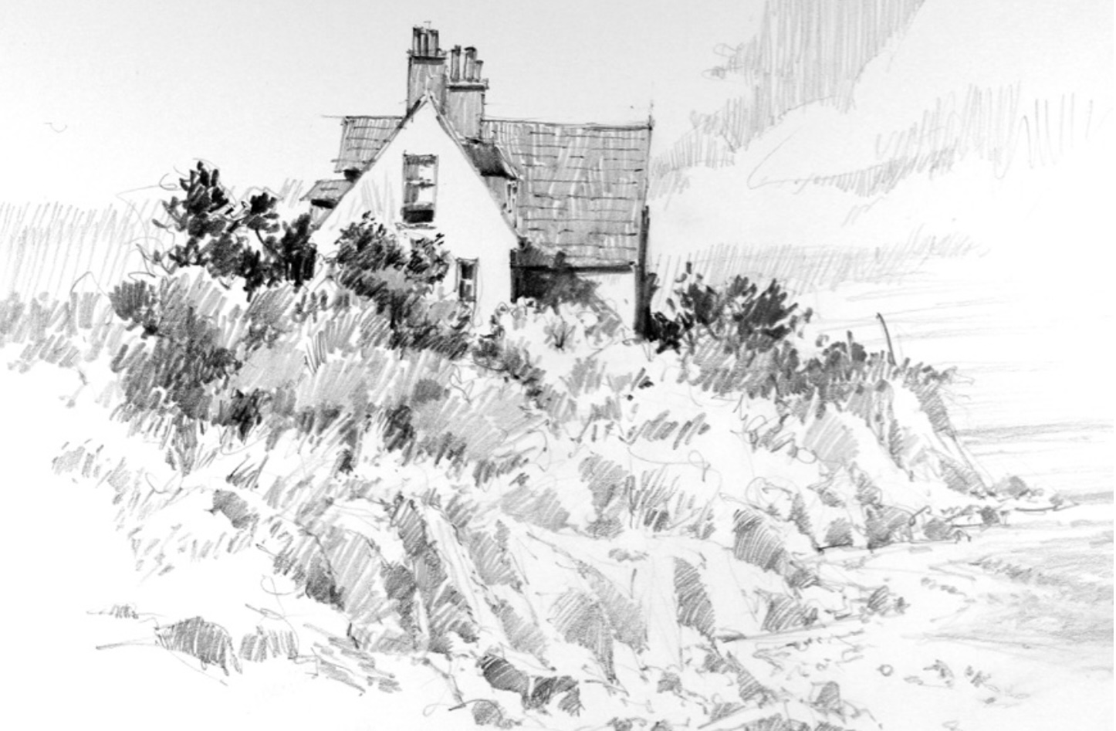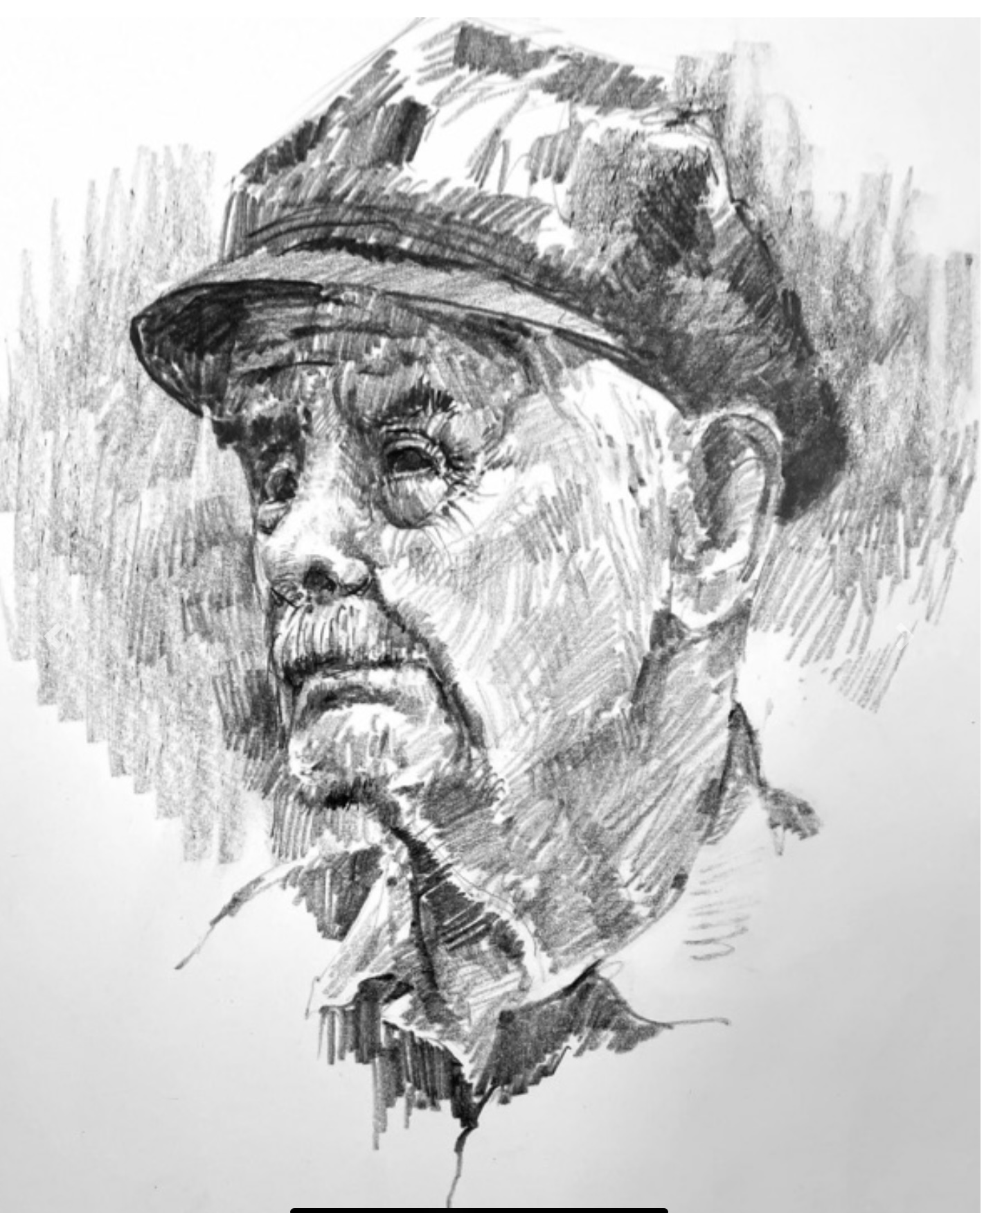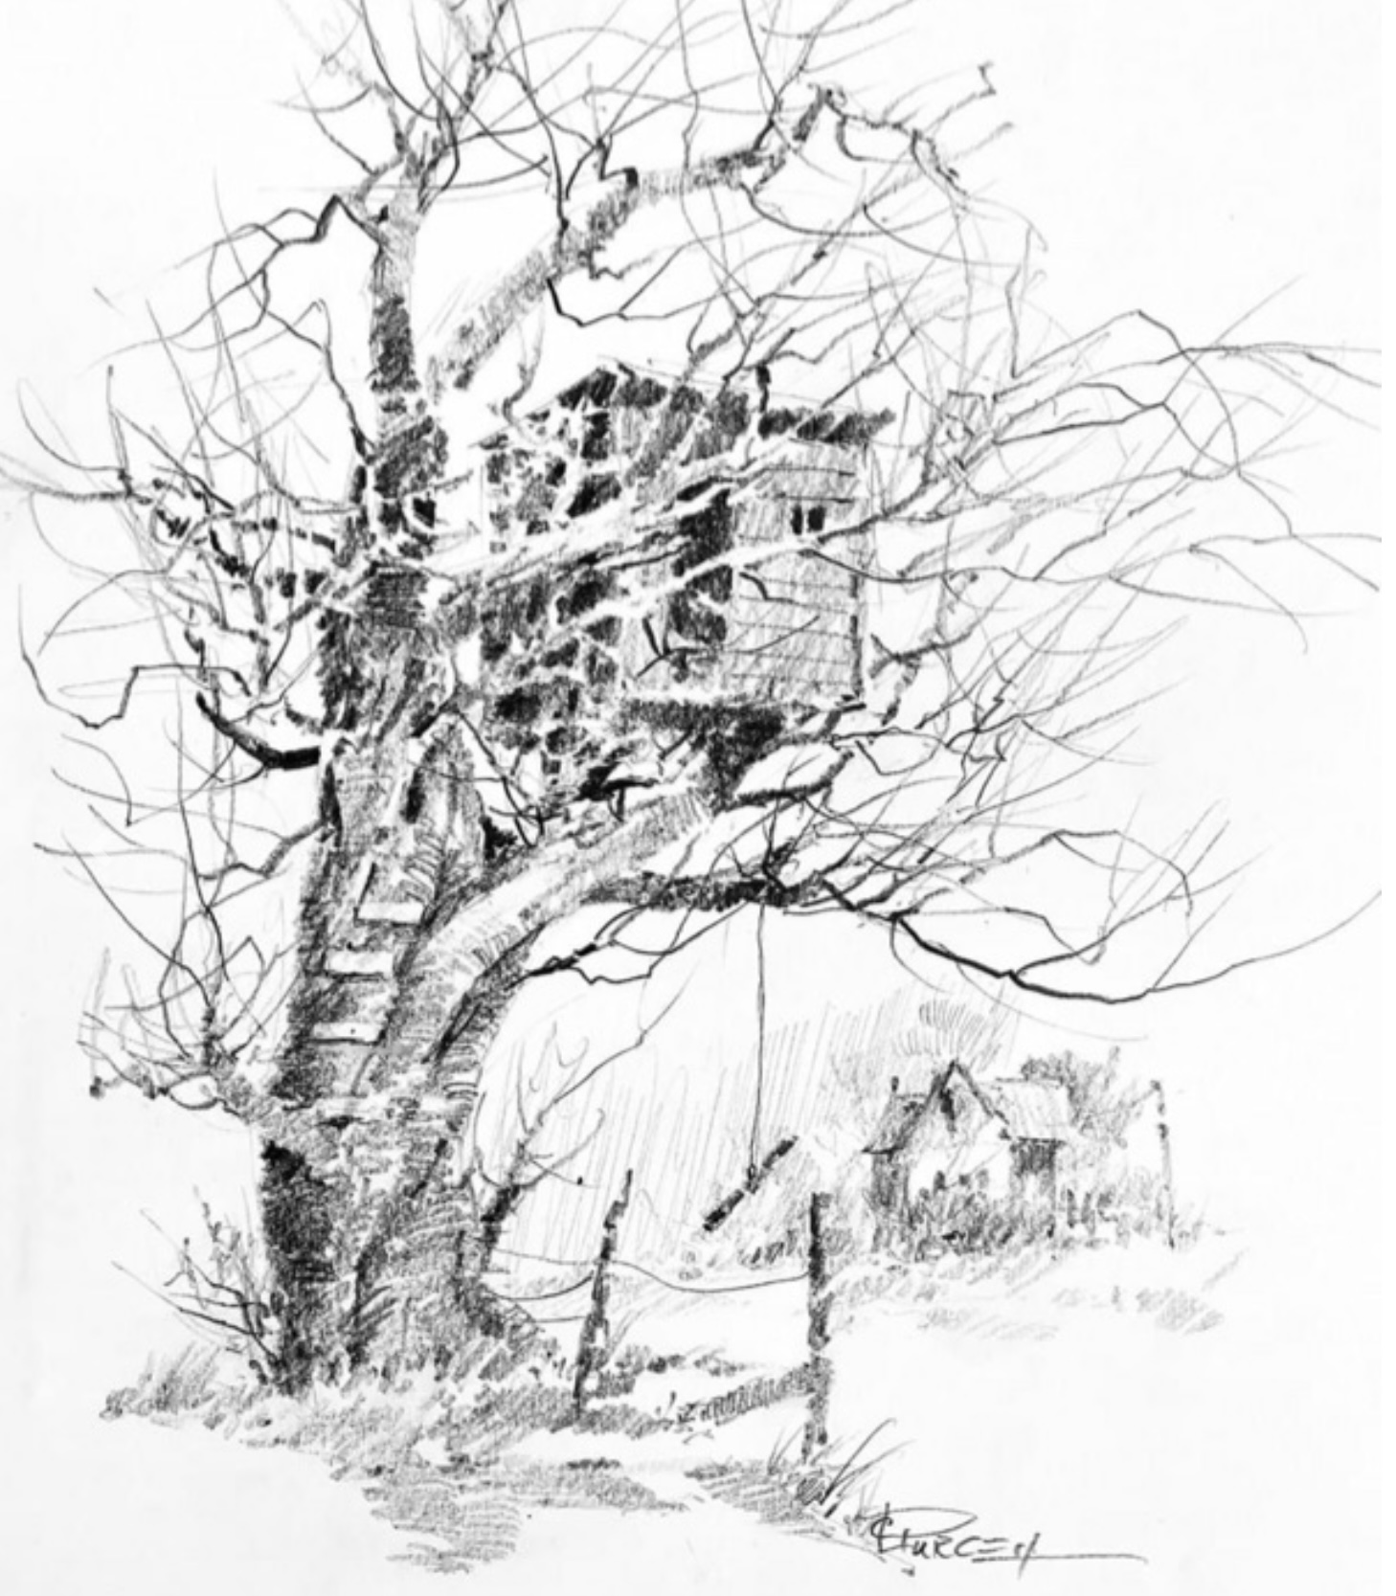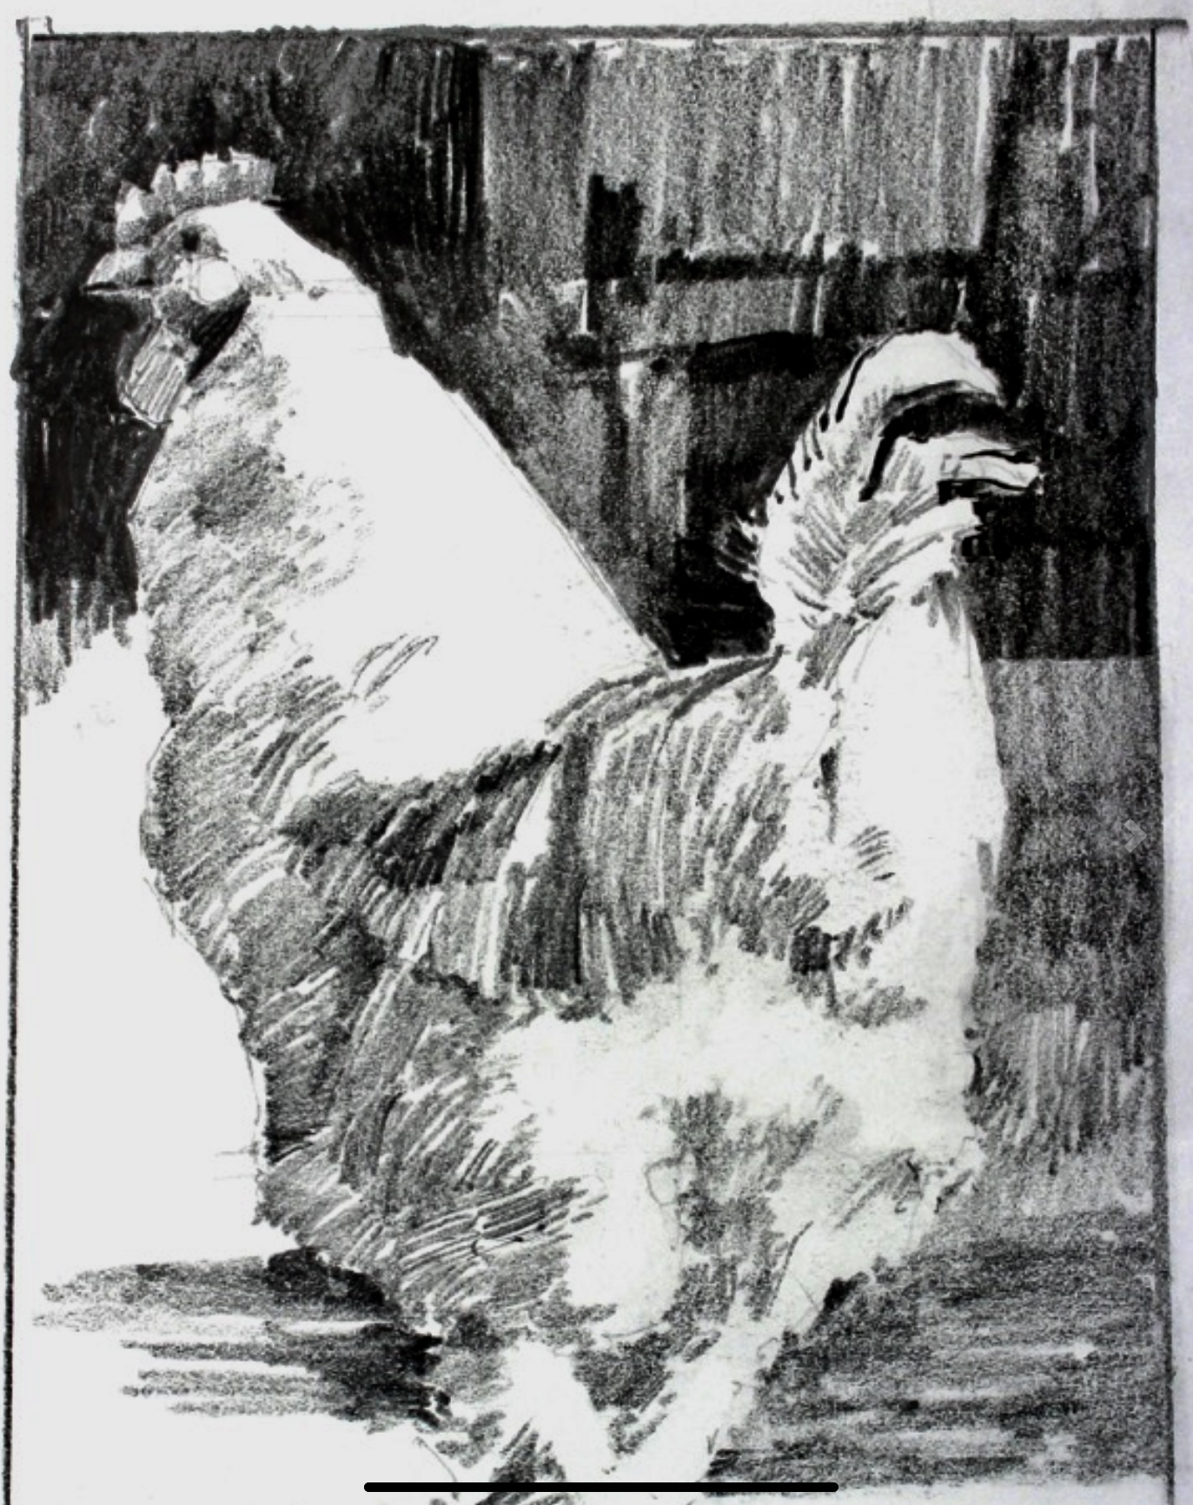
To register, go to:
NEVADAWATERCOLORSOCIETY.ORG
and sign up under the events list
For more information contact: Linda Smith
Email: lsmith.lv@outlook.com or call: 509-499-1156

